Differential Equations
Definitions
A differential equation is a mathematical equation that relates some function with its derivatives. In applications, the functions usually represent physical quantities, the derivatives represent their rates of change, and the differential equation defines a relationship between them.
Formally:
- A differential equation involves an unknown function y=f(x) and its derivatives f′(x),f′′(x),…
- It can be written in the form F(x,y,y′,y′′,…,y^{(n)})=0, where F is a given function.

Mathematical Context
- Linear Differential Equation:
  - This example demonstrates a first-order linear differential equation where the unknown function y and its first derivative appear to the power of one and are not multiplied together.
- Method of Integrating Factors:
  - The solution involves the method of integrating factors, a standard technique for solving first-order linear differential equations. This method transforms the equation into a form that can be integrated directly.
- General Solution:
  - The solution includes an arbitrary constant CCC, reflecting the infinite set of solutions that satisfy the differential equation for different initial conditions.

Applications
This type of linear differential equation appears in various mathematical models, including:
- Exponential Growth and Decay:
  - Used to model processes such as radioactive decay and population growth under certain conditions.
- Electric Circuits:
  - Describes the behavior of circuits containing resistors and capacitors (RC circuits).
- Mixing Problems:
  - Models the concentration of substances in mixing tanks or compartments over time.
Understanding and solving simple linear differential equations is fundamental in many areas of mathematics and its applications (See Fig. 1)

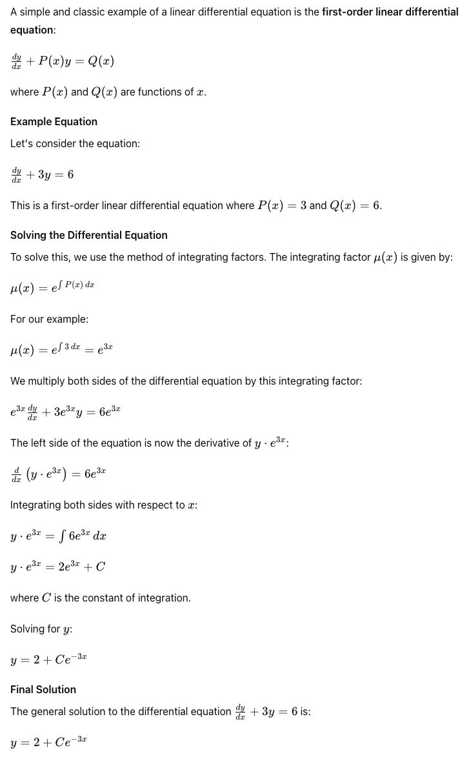
Fig. 1 An example of a linear differential equation and its solution
Simple Differential Equation Modeling Exponential Growth

Mathematical Context
- Exponential Growth:
  - This model describes situations where the rate of change of a quantity is directly proportional to the quantity itself. As the quantity grows, the rate of growth increases.
- Initial Value:
  - The constant A represents the initial amount of the quantity at t=0.
- Growth Rate:
  - The parameter r is the growth rate. If r>0, the quantity grows exponentially. If r<0, the quantity decays exponentially.

Applications
- Population Growth:
  - Used to model populations of organisms in an environment with unlimited resources.
- Investment Growth:
  - Describes the growth of investments with continuous compounding interest.
- Radioactive Decay (with r<0):
  - Models the decay of radioactive substances over time.
- Biological Processes:
  - Applies to various biological processes where growth is proportional to the current state.
Figure 2 below illustrates an example of a linear differential equation modeling exponential growth.

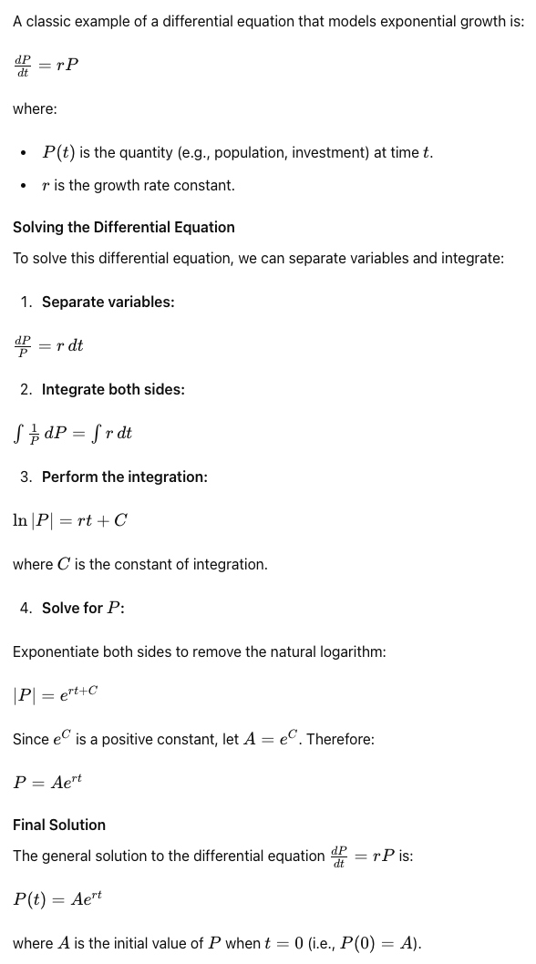
Fig. 2 A differential equation model for exponential growth

Example
This equation models the exponential growth of the bacteria population over time (Fig. 3).
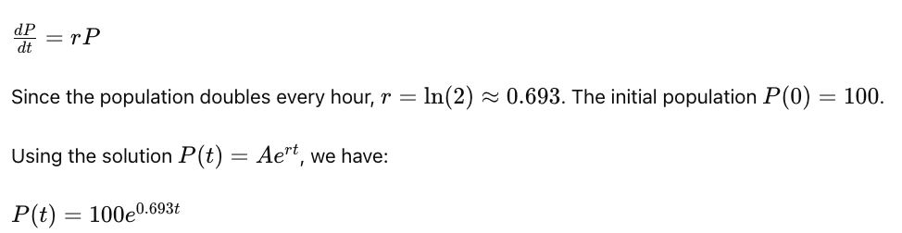
Fig. 3. Bacteria population growth

Broader Mathematical Context
Understanding differential equations is essential for modeling and solving real-world problems where quantities change continuously. Their study is a foundational aspect of applied mathematics, influencing a broad range of scientific and engineering disciplines.
- Calculus:
  - Differential equations are a natural extension of differential calculus, studying how functions change.
  - Fundamental to understanding motion, growth, decay, and other physical phenomena.
- Linear Algebra:
  - Used to solve systems of linear differential equations.
  - Eigenvalues and eigenvectors play a critical role in understanding solutions to linear systems.
- Complex Analysis:
  - Solutions to differential equations can often be understood in the context of complex functions and their properties.
- Numerical Methods:
  - Many differential equations cannot be solved analytically and require numerical methods for approximation.
  - Methods like Euler’s method, Runge-Kutta methods are widely used.
- Applied Mathematics:
  - Differential equations are ubiquitous in physics, engineering, economics, biology, and many other fields.
  - Examples: Newton’s laws of motion (classical mechanics), Maxwell’s equations (electromagnetism), Black-Scholes equation (financial mathematics).
Example Applications
- Physics:
  - Describes the motion of particles and systems (Newton's second law).
  - Electromagnetic fields (Maxwell's equations).
- Biology:
  - Models population dynamics (Lotka-Volterra equations).
  - Spread of diseases (SIR models).
- Economics:
  - Describes how economic variables evolve over time (Solow growth model).
- Engineering:
  - Analyzes circuits (Kirchhoff's laws).
  - Predicts structural behavior (beam deflection).
Types of Differential Equations
- Ordinary Differential Equations (ODEs):
  - Involve functions of a single variable and their derivatives.
  - Example $\frac{dy}{dx}+y= e^{x}$
- Linear vs. Nonlinear Differential Equations:
  - Linear: The function and its derivatives appear to the power of one.
    - Example: y′′+3y′+2y=0.
  - Nonlinear: Involve powers or products of the function and its derivatives.
    - Example: y′′+y²=0.
- Homogeneous vs. Non-homogeneous Differential Equations:
  - Homogeneous: The equation equals zero.
    - Example: y′′−y=0.
  - Non-homogeneous: Includes a non-zero function.
    - Example: y′′−y=e^{x}.

Uses in Artificial Intelligence and Machine Learning
- Modeling Neural Networks:
  - Differential equations can describe the dynamics of neural networks, especially in continuous-time models. They are used to model the rate of change of the state of neurons.
  - Example: The Hodgkin-Huxley model in computational neuroscience uses differential equations to describe the electrical characteristics of excitable cells like neurons.
- Optimization Algorithms:
  - Gradient descent, a fundamental algorithm in machine learning, can be seen as solving a differential equation where the parameters are updated based on the gradient of the loss function.
  - Example: The differential equation $\frac{dθ}{dt}=-∇L(θ)$ describes the continuous version of gradient descent.
- Reinforcement Learning:
  - In reinforcement learning, differential equations can be used to describe the evolution of value functions over time.
  - Example: The Hamilton-Jacobi-Bellman (HJB) equation is a partial differential equation used in optimal control and reinforcement learning to find the optimal policy.
- Generative Models:
  - Differential equations are used in models like Generative Adversarial Networks (GANs) to describe the dynamics of the generator and discriminator during training.
  - Example: The dynamics of GANs can be analyzed using differential equations to understand the stability and convergence properties of the training process.
- Time Series Analysis:
  - Many time series models, especially those dealing with continuous data, employ differential equations to model the evolution of the series over time.
  - Example: In financial modeling, the Black-Scholes equation, a partial differential equation, is used to model the prices of financial derivatives.

